Activity main.xml

<?xml version="1.0" encoding="utf-8"?>  
<androidx.constraintlayout.widget.ConstraintLayout xmlns:android="http://schemas.android.com/apk/res/android"  
 xmlns:app="http://schemas.android.com/apk/res-auto"  
 xmlns:tools="http://schemas.android.com/tools"  
 android:layout_width="match_parent"  
 android:layout_height="match_parent"  
 tools:context=".MainActivity">  
  
 <TextView  
 android:layout_width="wrap_content"  
 android:layout_height="wrap_content"  
 android:text="Hello World!"  
 app:layout_constraintBottom_toBottomOf="parent"  
 app:layout_constraintEnd_toEndOf="parent"  
 app:layout_constraintStart_toStartOf="parent"  
 app:layout_constraintTop_toTopOf="parent" />  
  
</androidx.constraintlayout.widget.ConstraintLayout>

Menu.xml

<?xml version="1.0" encoding="utf-8"?>  
<menu xmlns:android="http://schemas.android.com/apk/res/android">  
  
 <item  
 android:id="@+id/item1"  
 android:layout_width="wrap_content"  
 android:layout_height="wrap_content"  
 android:title="helo" />  
 <item  
 android:id="@+id/item2"  
 android:layout_width="wrap_content"  
 android:layout_height="wrap_content"  
 android:title="about us" />  
 <item  
 android:id="@+id/item3"  
 android:layout_width="wrap_content"  
 android:layout_height="wrap_content"  
 android:title="Item" />  
</menu>

Theme.xml

<resources xmlns:tools="http://schemas.android.com/tools">  
 <!-- Base application theme. -->  
 <style name="Base.Theme.OptionMenu" parent="Theme.MaterialComponents.DayNight.DarkActionBar">  
 <!-- Customize your light theme here. -->  
 <!-- <item name="colorPrimary">@color/my_light_primary</item> -->  
 </style>  
  
 <style name="Theme.OptionMenu" parent="Base.Theme.OptionMenu" />  
</resources>

mainActivity.java

package com.example.optionmenu;  
  
import androidx.appcompat.app.AppCompatActivity;  
  
import android.os.Bundle;  
import android.view.Menu;  
import android.view.MenuInflater;  
import android.view.MenuItem;  
import android.widget.Toast;  
  
public class MainActivity extends AppCompatActivity {  
  
 @Override  
 protected void onCreate(Bundle savedInstanceState) {  
 super.onCreate(savedInstanceState);  
 setContentView(R.layout.*activity_main*);  
 }  
  
 @Override  
 public boolean onCreateOptionsMenu(Menu menu){  
 MenuInflater inflater = getMenuInflater();  
 inflater.inflate(R.menu.*menu1*,menu);  
 return true;  
  
 }  
 public boolean onOptionsItemSelected(MenuItem item)  
 {  
 if(item.getItemId()==R.id.*item1*)  
 {  
 Toast.*makeText*(this,"item1",Toast.*LENGTH_SHORT*).show();  
 }else if (item.getItemId()==R.id.*item2*){  
 Toast.*makeText*(this,"item2",Toast.*LENGTH_SHORT*).show();  
 }  
 else {  
 Toast.*makeText*(this,"item1",Toast.*LENGTH_SHORT*).show();  
 }  
 return true;  
 }  
  
  
}

output

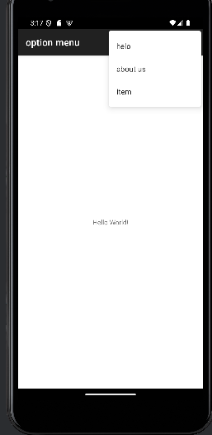

Listmenu